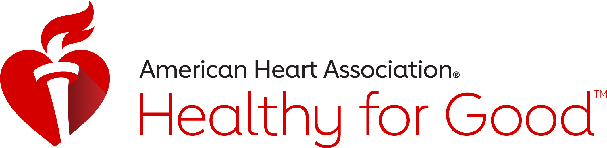

Healthy Living For All … Why? Life. Life is why.
Locally Sponsored By


April 2023

Dear Friends,
Let’s MOVE MORE … ALL YEAR LONG! Staying active is very important. We are on a mission to be Healthy for Good™ every day.

Find Your Fierce in Movement! Being active is one of the best ways to maintain your physical and mental health. Not only can movement help you feel, function and sleep better, but it can also improve your mood and overall quality of life.

Penn Medicine Princeton Health and the American Heart Association are pleased to share with you this 2023 American Heart Association National MOVE MORE resource toolkit. We encourage you to take an active role to foster and support a culture of movement and activity, even virtually, throughout your organization and in your individual lives. Look for ways you or your audience can get more active throughout the day.
Physical activity leads to better brain health, sleep, memory and overall quality of life. Even small amounts of physical activity improve health, so let’s get MOVING … ALL MONTH LONG … ALL YEAR LONG. Penn Medicine Princeton Health and the American Heart Association encourage your audience/employees to find more ways to move throughout your day and to hold MOVEMENT MEETINGS. Hold fun, healthy National MOVE MORE activities, contests or challenges in-person or virtually throughout the year.
You’ll find supporting messaging, resources, infographics, activities, access to video movement breaks and additional ideas and materials within this FREE National MOVE MORE resource kit. Find additional resources and learn more by visiting heart.org/MOVEMORE.
Thank you for supporting American Heart Association Healthy For Good™, the National MOVE MORE observance and the importance of being active by MOVING MORE. MOVE MORE and Make it Count!
Sincerely,

James G. Demetriades, MBA
Chief Executive Officer
Penn Medicine Princeton Health

American Heart Association, New Jersey Office, 250 Pehle Avenue, Suite 202, Saddle Brook, New Jersey, 07663 (609) 208-0020
©2023, American Heart Association. Also known as the Heart Fund.


