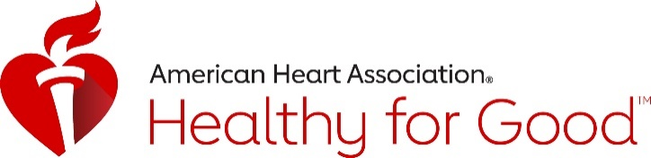
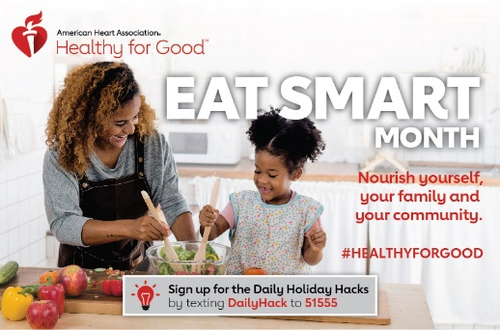

Observe and Promote 2020 National EAT SMART Month, EAT SMART Day with …
IDEAS/Content for Awareness via Social Media
Share as many of the following social media messages as you can or wish to promote AHA National EAT SMART Day on November 4, or AHA National EAT SMART Month (November). You can share posts from the American Heart Association New Jersey’s page at Facebook.com/AmericanHeartNJ or RT us on Twitter @AHANewJersey. Also, follow us on Instagram @AHANewJersey. Tagging us in your posts makes us happy, too! Please remember to include #LifeisWhyNJ in all your posts!

Facebook Messages, now through November 4, National EAT SMART Day, & ALL Nov.!
- #EatSmart during the month of November and get #HealthyForGood with the American Heart Association. https://healthyforgood.heart.org/eat-smart #LifeisWhyNJ #EatSmart
- This November, commit to get #HealthyForGood and #EatSmart as an individual, family, community, school or company. Learn more at https://healthyforgood.heart.org/eat-smart #LifeisWhyNJ
- There are many ways to be #HealthyForGood, whether it’s grilling, steaming, sautéing, or baking. What’s your favorite way to #EatSmart? https://healthyforgood.heart.org/eat-smart #LifeisWhyNJ
- Make healthier food choices easier by taking part in AHA Eat Smart Month in November. Get #HealthyForGood and sign up for your free toolkit at https://healthyforgood.heart.org/eat-smart #LifeisWhyNJ
- Today, Nov. 4, is AHA National EAT SMART Day! Learn more and find tips: www.heart.org/eathealthy #LifeisWhyNJ #EatSmart

Twitter Messages, now through November 4, National EAT SMART Day & ALL Nov.!
- #EatSmart this November and get #HealthyForGood with @AHANewJersey https://healthyforgood.heart.org/eat-smart #LifeisWhyNJ
- This Nov. 4, commit to get #HealthyForGood and #EatSmart as an individual, family, or community. heart.org/eatsmartmonth #LifeisWhyNJ
- Grilling, steaming, sautéing, or baking, the goal is to #EatSmart. heart.org/eatsmartmonth #HealthyForGood #LifeisWhyNJ
- Nov. 4 is AHA National EAT SMART Day. How will you be #HealthyForGood? heart.org/eatsmartmonth #LifeisWhyNJ
- It’s AHA National EAT SMART Day! Learn how to be #HealthyForGood with @AHANewJersey heart.org/eatsmartmonth #LifeisWhyNJ
- Make healthier food choices easier by taking part in AHA Eat Smart Month. Learn more: heart.org/eatsmartmonth. #HealthyForGood #LifeisWhyNJ

©2020, American Heart Association. Also known as the Heart Fund.

